Survivors, please make a video and send it to us

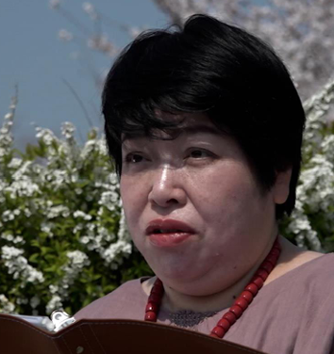    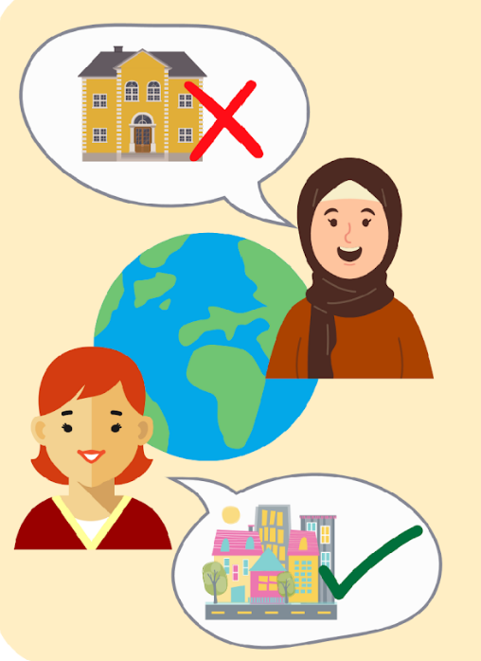  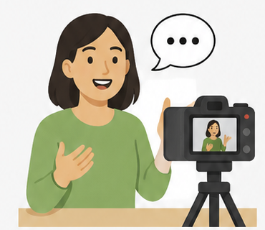 | My name is Chiaki Nakayama.  I am a self-advocate from Japan and a survivor of institutions.  Inclusion International has a global network for survivors of institutions.  This group is called the Survivors Network.  I am the chair of the Survivors Network.  An institution is any place where people with disabilities:  - are separated from the community.  - do not have control over their lives and the day-to-day decisions like who cares for them and what they do with their time.  - do not have their rights respected  An institution can be large when many people live together in the same place.  Or small with only a few people.  Institutions can have many different names.  Survivors of institutions are people who:  - have lived in institutions and have left and now live in the community.  - still live in institutions but are trying to leave.  The Survivors Network of Inclusion International wants more people to understand institutions and survivors' experiences.  To help this happen, we are collecting videos from survivors.  The videos will help us advocate for institutions to close.  This booklet tells survivors what we would like them to talk about in their video about deinstitutionalisation.
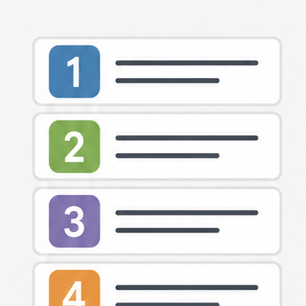 | We would like to hear:  • Why you lived in an institution.  • What it was like to live there.  • How you moved to living in the community.  • How your life is different now.  • Your message!  More details are explained in the next pages.

Question 1 and Question 2

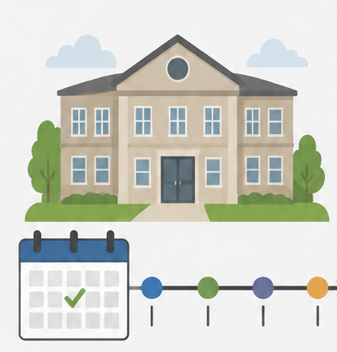 | Question 1  Why did you start to live in an institution?  How long were you living there?
 | Question 2  What was your experience of living in an institution? How did you feel while you were living there?

Question 3 and Question 4, Question 5

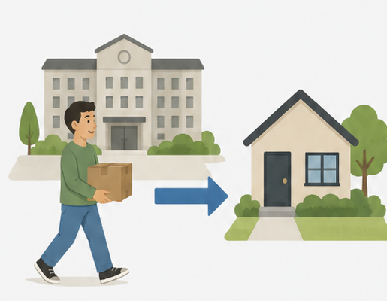 | Question 3  How did you transition to living in the community? Is there anyone who helped you or given advice to you?
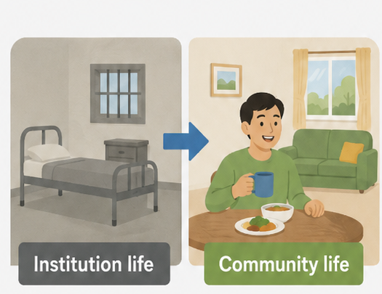 | Question 4  What are the differences between your life in an institution and your life in the community?  Are you living the life you want? What kind of help are you receiving?
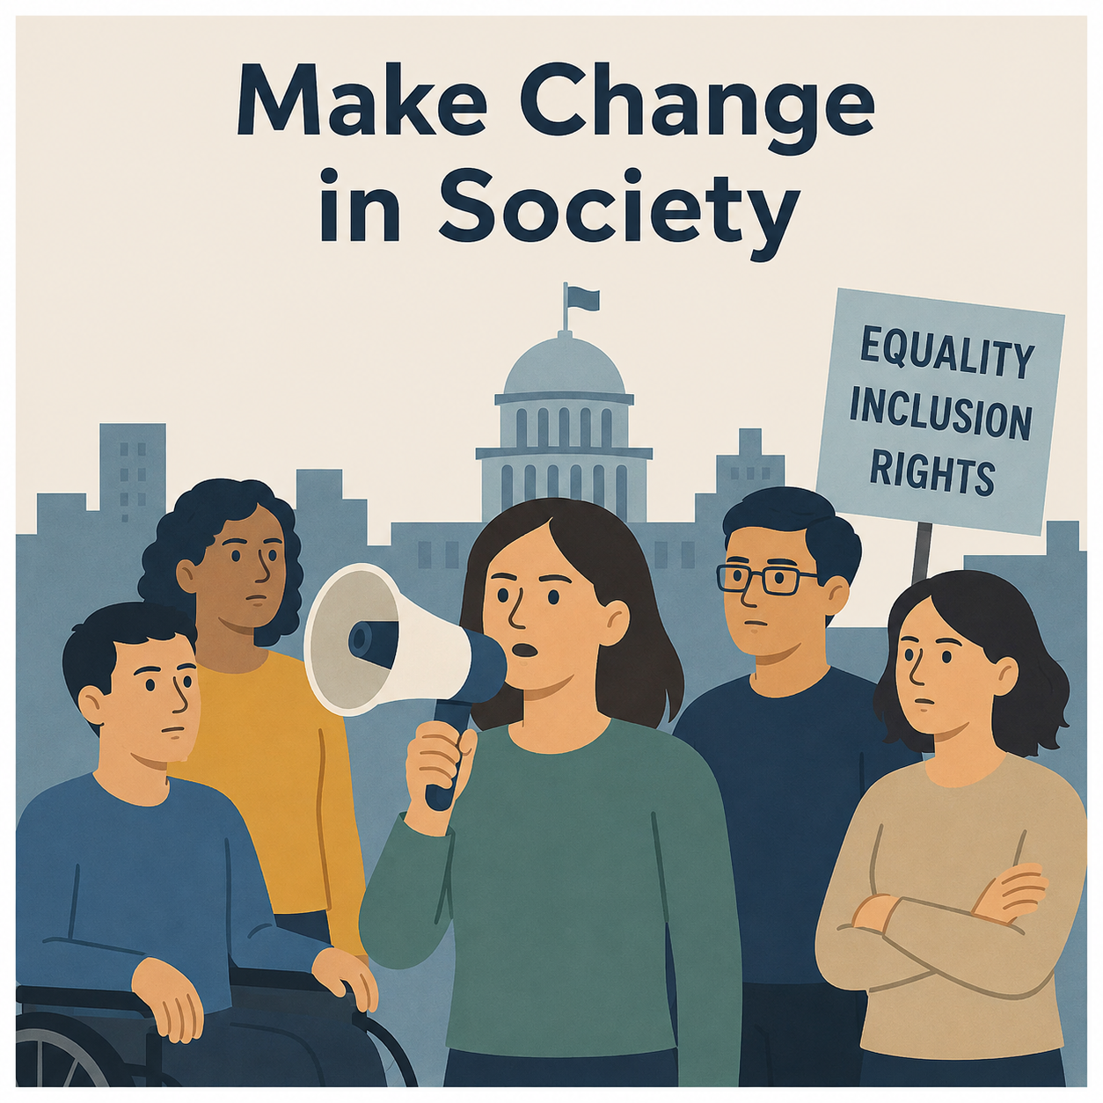 | Question 5  What you would like to say to the government and society.  Is there any message for the people who still live in institutions now?

How to film the video

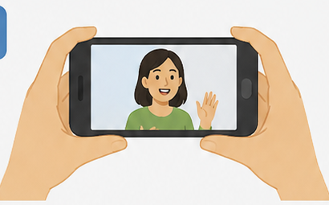 | If you are filming with a smartphone, please hold it horizontally.
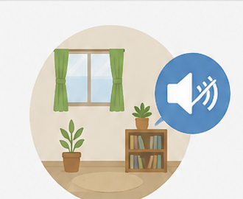 | Please film in a quiet place so that your voice can be heard clearly.
 | Please keep the camera as steady as possible by using a tripod.  Or, please ask someone to hold the camera for you.
 | It may be easier to talk if someone asks you the questions, like a conversation.

Please keep the video to about 8-10 minutes at most.

How to send your video

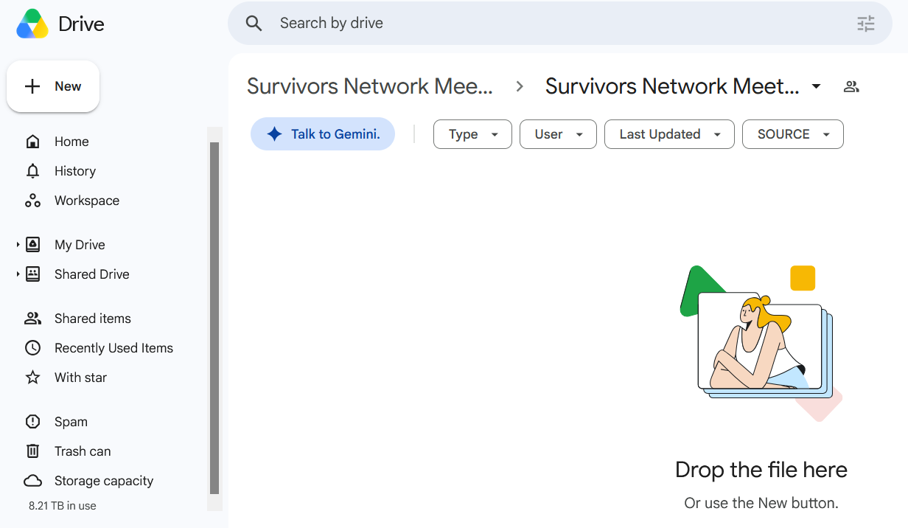 | - Google Drive  If you have a Google account, you can upload your video directly to the shared Google Drive folder.  https://drive.google.com/drive/folders/1NJ9TTlEx0CuV-7JOHF0HsAzBpSlsh5Cv?usp=sharing  
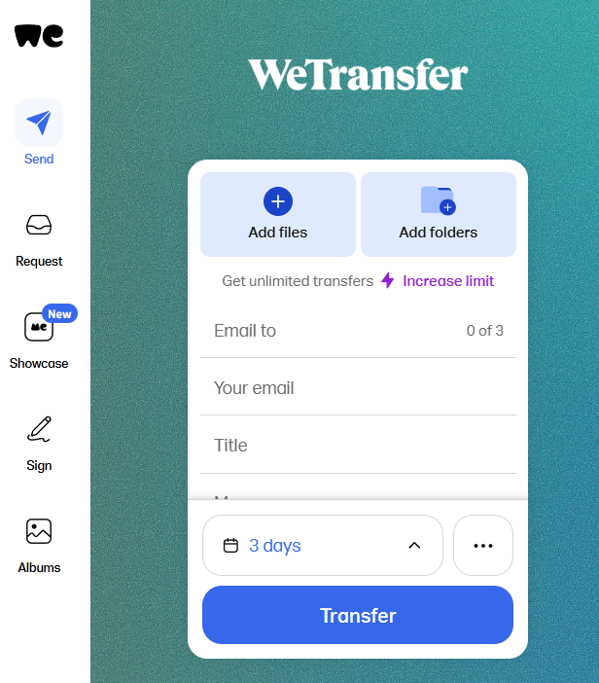 | - WeTransfer  You can also use this free service to upload your video.  https://wetransfer.com/  For [Email to], please enter the following email address:  ailis.hardy@inclusion-international.org
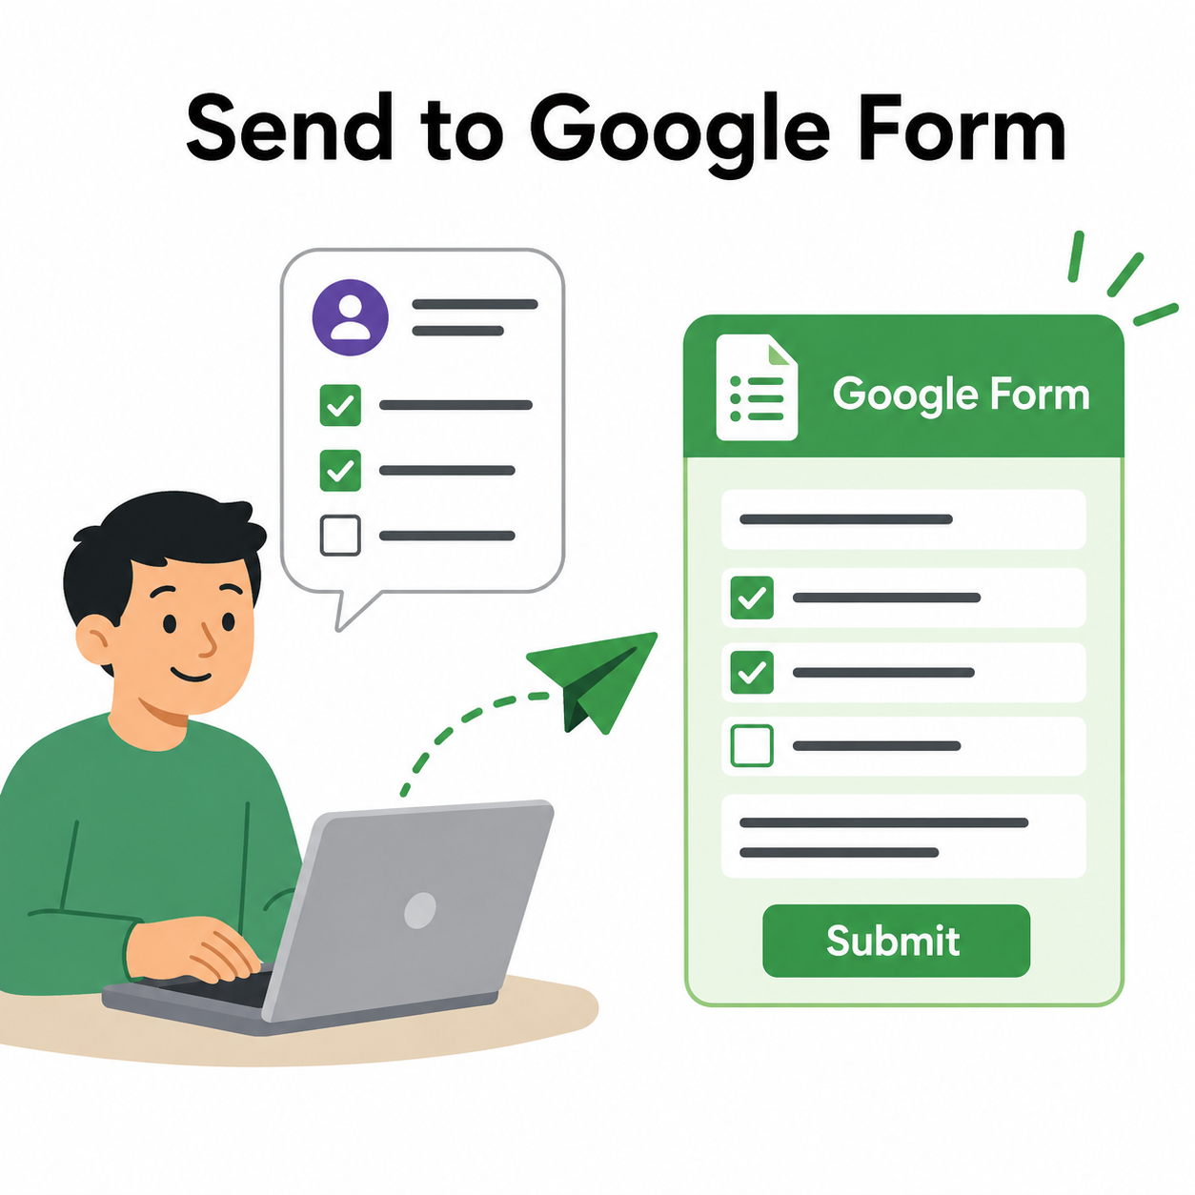 | After sending your video  Please complete the Google Form to let us know.  https://forms.gle/4H8JDcrfD7QmVZg19  
 | The submission deadline is the end of September 2026.

